Suman Paudel (33)

Assignment IV

# Lab 4:

**Prepare Lab Sheet of MYSQL Statements for following.**

1. Create tables Teacher (Id INT PRIMARY KEY, Tname VARCHAR(20)) and Student (id INT PRIMARY KEY, Sname VARCHAR(20));

**SQL Script**:

**CREATE** **TABLE** Teacher (

Id **INT** **PRIMARY** **KEY**,

Tname **VARCHAR**(20)

);

**CREATE** **TABLE** Student (

Id **INT** **PRIMARY** **KEY**,

Sname **VARCHAR**(20)

);

**Output:**

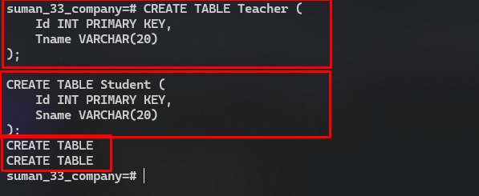

1. Insert values like {(“1,”Ram”), (2,”Hari”), (3,”Sita”)} in Teacher and {(“2,”Hari”), (3,”Sita”), (4,”Gita”)} in Student.

**SQL Script:**

**INSERT** **INTO** ***Teacher*** (***Id***, ***Tname***) **VALUES**

(1, **'Ram'**),

(2, **'Hari'**),

(3, **'Sita'**);

**INSERT** **INTO** ***Student*** (***Id***, ***Sname***) **VALUES**

(2, **'Hari'**),

(3, **'Sita'**),

(4, **'Gita'**);

**Output:**

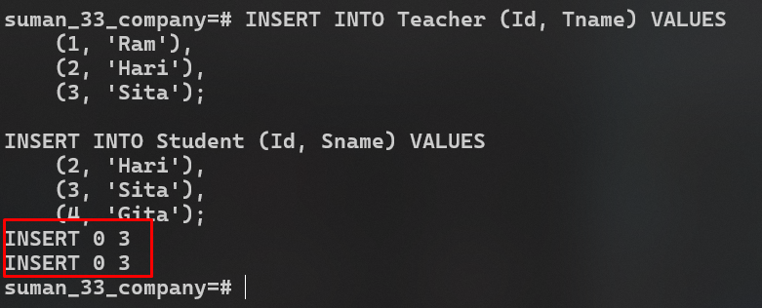

1. Write query to find Union of Teacher and Student.

**SQL Script:**

**SELECT** * **FROM** ***Teacher***

**UNION**

**SELECT** * **FROM** ***Student***;

**Output:**

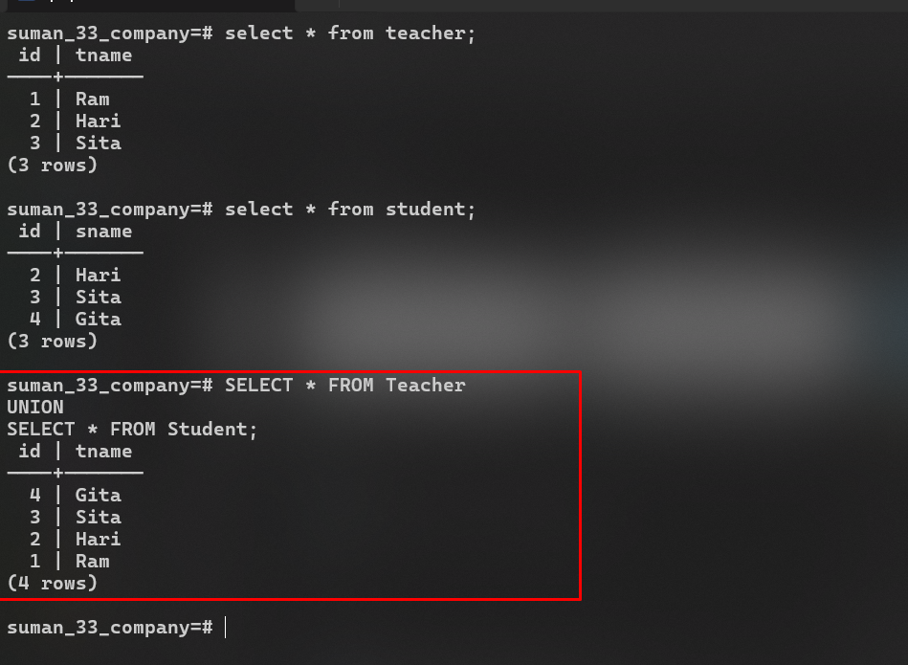

1. Write query to find Intersection of Teacher and Student.

**SQL Script:**

**SELECT** * **FROM** ***Teacher***

**INTERSECT**

**SELECT** * **FROM** ***Student***;

**Output:**

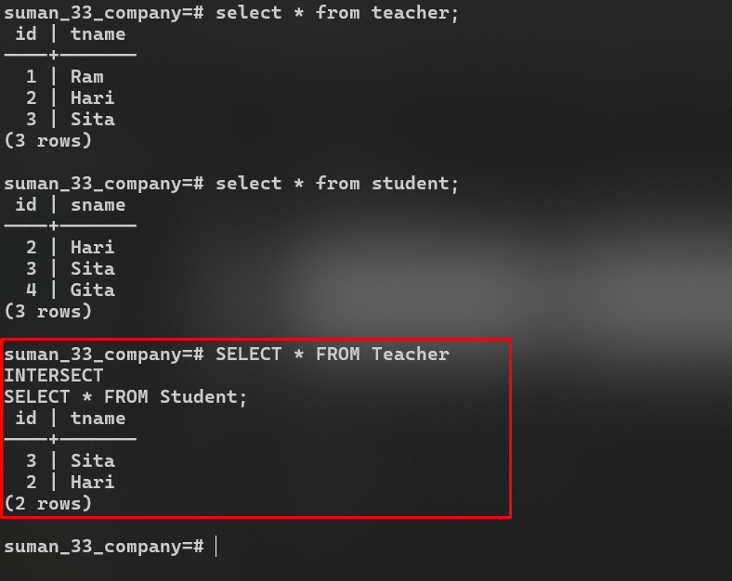

1. Write query to find intersection of names Teacher and Student using Distinct and Inner Join.

**SQL Script For Left Join:**

**SELECT** **DISTINCT** *t*.***Tname***

**FROM** ***Teacher*** *t*

**INNER** **JOIN** ***Student*** *s* **ON** *t*.***Tname*** = *s*.***Sname***;

**Output:**

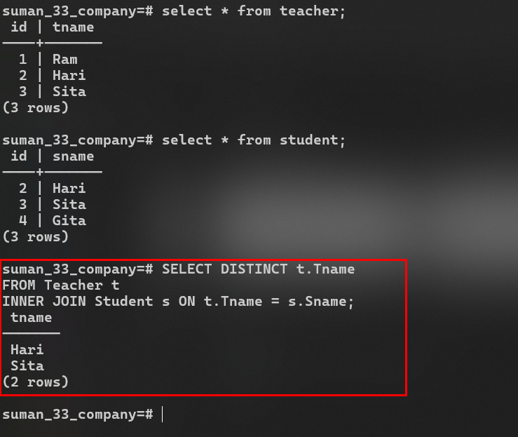

1. Write query to find intersection of names Teacher and Student using IN and Sub query.

**SQL Script:**

**SELECT** Tname

**FROM** Teacher

**WHERE** Tname **IN** (**SELECT** Sname **FROM** Student);

**Output:**

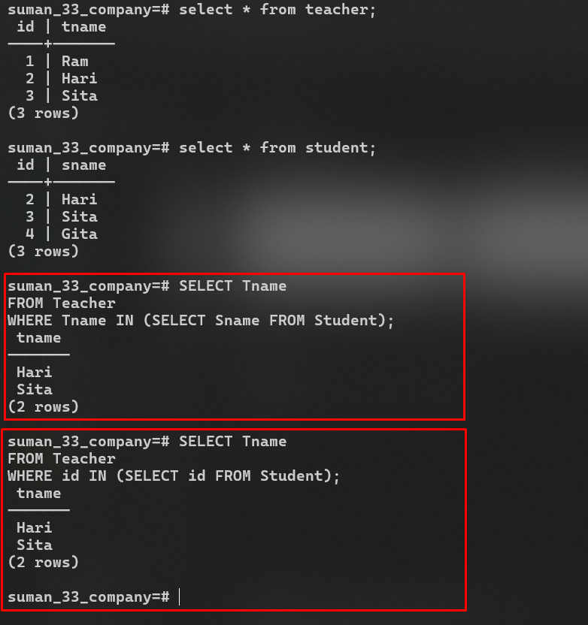

1. Write query to find Teacher MINUS Student using Left Join.

**SQL Script:**

**SELECT** t.Tname

**FROM** Teacher t

**LEFT** **JOIN** Student s **ON** t.Tname = s.Sname

**WHERE** s.Sname **IS** **NULL**;

**Output:**

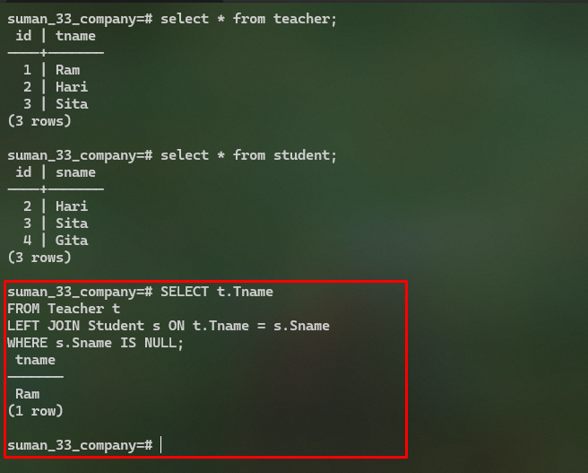

1. Find the number of offices in the Office table from the COMPANY Database in Lab-1 using COUNT function.

**SQL Script:**

**SELECT** **COUNT**(*) **AS** num_offices

**FROM** Office;

**Output:**

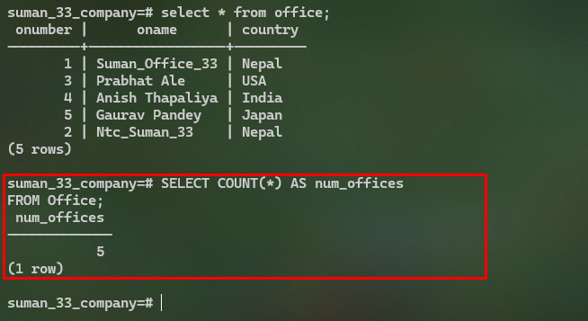

1. Write a query to count the distinct names of Employees.

**SQL Script:**

**SELECT** **COUNT**(**DISTINCT** Ename) **AS** distinct_names

**FROM** Employee;

**Output:**

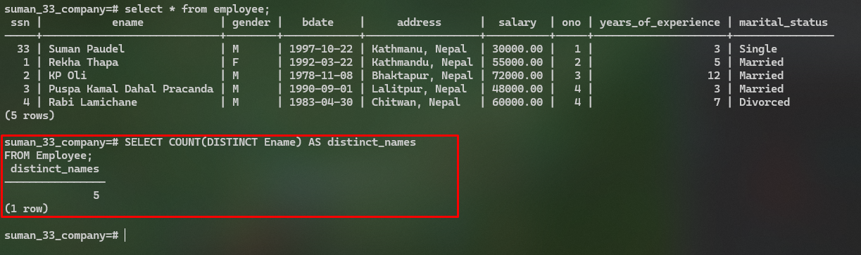

1. Write a query to find sum of salary of Employees.

**SQL Script:**

**SELECT** **SUM**(Salary) **AS** total_salary

**FROM** Employee;

**Output:**

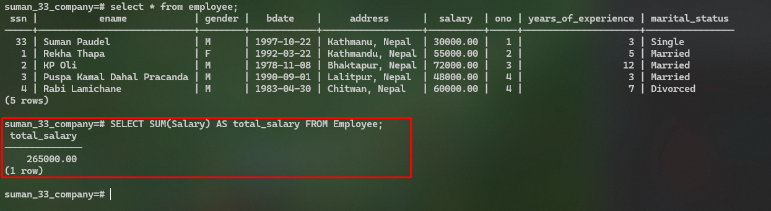

1. Write a query to find average of salary of Employees.

**SQL Script:**

**SELECT** **AVG**(Salary) **AS** avg_salary

**FROM** Employee;

**Output:**

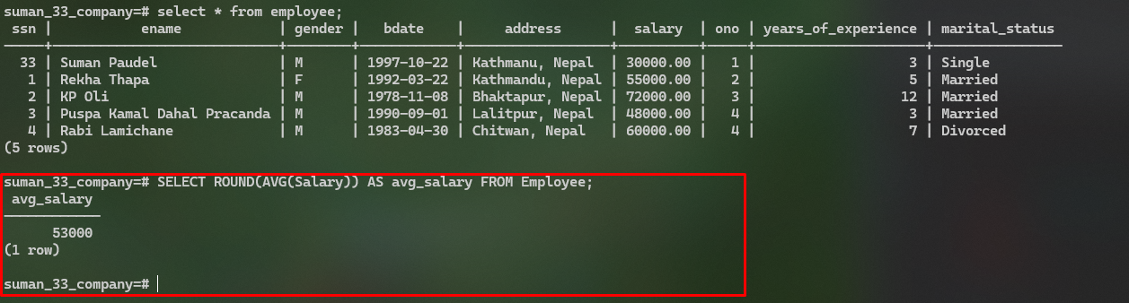

1. Write a query to find Maximum PF Amount from the PF Table.

**SQL Script:**

**SELECT** **MAX**(PFAmount) **AS** max_pf_amount

**FROM** PF;

**Output:**

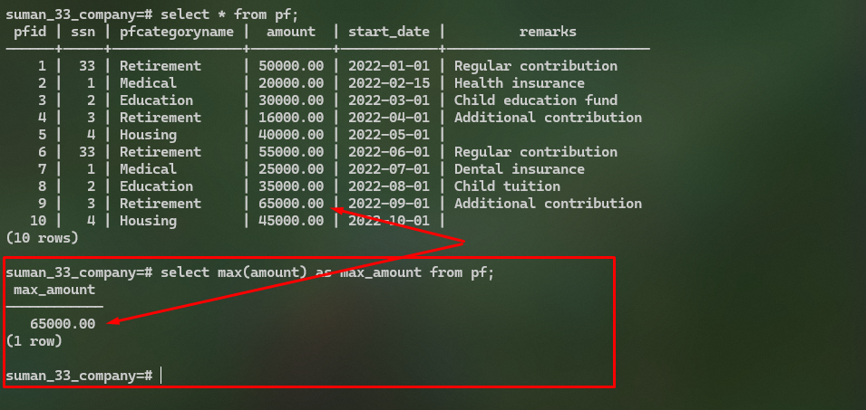

1. Write a query to find Minimum PF Amount from the PF Table.

**SQL Script:**

**SELECT** **MIN**(PFAmount) **AS** min_pf_amount

**FROM** PF;

**Output:**

